# ScholarshipUniverse

* Log into ScholarshipUniverse and type the student’s UVUID number into the search bar located at the top right-hand corner of the homepage to pull up the “Student Profile.”

## Student Profile

* On the landing page, you will see the student’s photo (if they’ve provided one), name, and UVUID number on the left side of the page.
* **Sensitive data on the student’s account, which you may or may not have access to based on your position, will appear as ***.**
* If the student’s data does not appear or is listed as N/A, then their data is no longer being imported into ScholarshipUniverse.
  + Currently, data is imported into ScholarshipUniverse if a student was enrolled in the last 7 semesters, has an LOA that does not expire in the next year, has recently been admitted, or has a Y on ROAUSDF in Element 275.
* A close-up of a card

  Description automatically generatedOn the right side of the page, you will see the following:
* **Lifetime Awarded to Date:** the amount of scholarship awards the student has received total (not including Banner-Only awards like Greenlight, Reach, or USHE).
* **20xx-20xx Awards:** ScholarshipUniverse lists the current and future award years and the amounts the student is awarded for each year.
* **Applications Completed:** the number of applications the student filled out and submitted.
  + This number is not the number of scholarships the student has applied for, as applications can apply students to multiple scholarships.
  + The number listed does not include applications in progress.
* **Scholarship Matches:** the number of scholarships the student has matched to, including both institutional (direct award and application-based) and external scholarships.
* On the bottom of the landing page, you will see the following tabs:
* Each tab provides you access to different student information. You may view the student’s information by clicking on the applicable tab.

### Action Required Tab

* 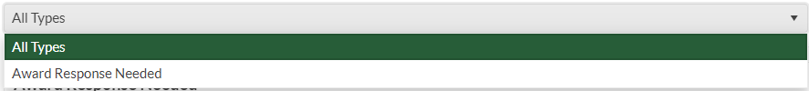The dropdown menu shows “All Types” by default, but if you wish to see something specific you may narrow down what is displayed by clicking on the type you wish to see.
  + Usually, it is only the “Award Response Needed” type to appear on this tab.
* On the “Action Required” tab, you can also see what scholarships the student has yet to accept, and the deadline for acceptance.
  + Students risk having their scholarship award offer canceled if they do not accept their award by the listed date.

### Student Data Tab

* The “Student Data Tab” has two dropdown menus:
  + A green and white number

    Description automatically generated**Award Year:** allows you to select the specific school year you wish to see.
  + **Category:** allows you to view specific information regarding the student.
    - A screenshot of a computer

      Description automatically generatedThe information listed updates 1-2 business days after a change is issued on Banner.

#### Academic Category

* A white rectangular object with a black border

  Description automatically generatedThe Academic Category will display the following:
  + **Admit Term:** the term the student officially became admitted to UVU, which does not necessarily mean they were enrolled during this term.
  + **Current Term:** the current term of the award year, which, although displayed, does not necessarily mean they are enrolled during this term.
  + **Declared Minor:** if the student is in a minor program, it will be listed here.
  + **Graduate Completed Hours:** the number of hours completed for a Graduate program.
    - If the student isn’t enrolled in a Graduate program and never has been, then it will be 0.
  + **Graduate Level:** will show if they’re an Undergraduate student or a Graduate student.
  + **Program School:** the college through which the student’s degree program is offered.
  + **Transfer GPA:** if they’re a transfer student, the GPA that was listed on their most recent transcript loaded into Banner will appear here.
  + **Undergraduate Completed Hours:** the number of credit hours the student has completed thus far.
    - If they’re a new student, then it will be 0.
  + **Current Enrollment Hours:** the number of credit hours in which the student is currently enrolled.
  + **Declared Major:** the major the student is registered under.
    - If it is a high school concurrent enrollment student, it will state as such.
  + **Grade Level:** if they are a Freshman, Sophomore, Junior, or Senior, it will be listed here.
  + **Graduate GPA:** if they’re a Graduate student, their GPA is shown here; otherwise, it will be listed as a 0.
  + **Institutional Degrees Earned:** the level of degree the student has already completed and earned.
    - If they have yet to earn a degree, what’s displayed is NONE.
  + **Transfer Degrees Earned:** if the student earned a degree at another institution, and we have record of it, then the degree earned is shown here.
  + **Transfer Hours:** the number of transfer credit hours accepted by UVU, which are the credit hours used for Transfer Merit Scholarship purposes.
  + **Undergraduate GPA:** the student’s current cumulative GPA.

#### Admissions Category

* The Admissions Category is incredibly useful when dealing with Incoming Freshman students, as it will display much of the eligibility criteria needed to award students.
  + As always, cross-check the information on ScholarshipUniverse with the information on Banner to ensure there are no errors.
* A white background with black and white clouds

  Description automatically generatedThe Admissions Category contains the following information:
  + **ACT:** the highest ACT score we have on file, which can include the Composite Superscore.
  + **High School Graduation Date:** the date the student graduated high school or is expected to graduate high school, according to the information listed on the transcript provided to Admissions.
  + **High School Transcript Received:** the date that Admissions received their transcript.
    - If you’re looking at an Incoming Freshman student, if the transcript was received later than March 1st of the year they’re graduating, they are likely ineligible.
  + **Transfer Transcript Received:** if the student is a transfer student, then the date we received their college transcript is listed here.
  + **High School GPA:** the GPA the student graduated with or is expected to graduate with, based on the most recently received transcript.
  + **High School Name:** the name of the high school the student graduated from.
    - If the student was homeschooled or earned a GED, it will be stated as such.
  + **Residency:** the student’s residency status according to Admissions.

#### Finance Category

* The Finance Category contains the following information:
  + **EFC:** the estimated family contribution number determined through the student’s completion of FAFSA.
    - We use this number for need-based scholarships.
    - If the student did not complete a FAFSA or we do not have an EFC on file, the number displayed is 999999.
  + **Scholarship Term Limit:** the number of terms the student may still receive a scholarship.
    - **T**he majority of UVU’s scholarships only allow students to receive 8 semesters of institutional scholarships.
  + **FAFSA:** if the student submitted a FAFSA, and we received it, then it will show Yes; otherwise, it will display No.
  + **Upcoming Unmet Need:** always displays N/A, as we do not use this information.
    - Use the Banner page RPAAWRD if you’d like to see how much unmet need the student has. It will need to be calculated.

#### Miscellaneous Category

* The Miscellaneous Category contains the student’s biographical information like name, address, email, gender, etc.

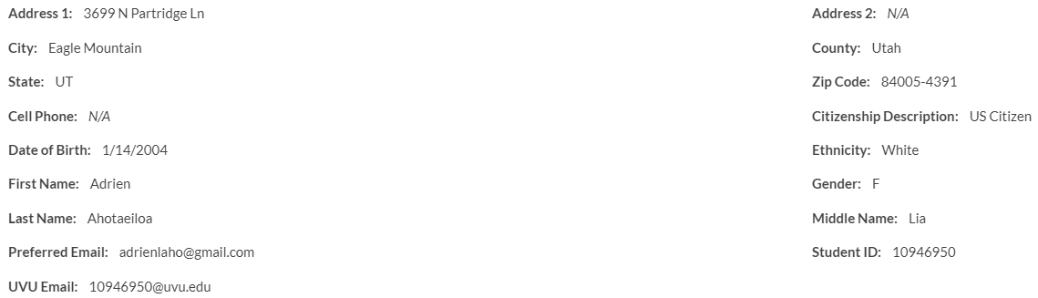

### MATCHING ANSWERS Tab

* The “Matching Answers” tab lists all the questions the student answered, what their answer is, and the date they last answered it. For an example, see below:
* This tab can be helpful when checking to see if a student answered a question correctly to allow them to be considered for the scholarship they wish to receive. Some of the criteria can be filtered by clicking on the funnel symbol, allowing ease in your search.



### ScholarshipS Tab

* The “Scholarships” tab allows you to view specific scholarship information for the student, such as the scholarships they’ve applied for and been matched to.
* A screenshot of a computer

  Description automatically generatedTo see each category, use the dropdown menu, as shown below:
* A screenshot of a computer

  Description automatically generatedIn each category, there are eight columns, as shown below:
* If you’re looking for a specific scholarship, department, status, or organization, they can be filtered by clicking on the funnel in the right-hand corner of each column.



* + **Scholarship:** the name of the scholarship.
  + **Amount:** the amount listed in this columnis typically shown as “Varies.”
    - We generally do not put in the actual amount of the award, as the amounts vary from year to year and student to student.
  + **Apply Between:** the dates the application is open and can be applied for.
  + **Organization:** the organization or school/college the scholarship is offered through.
    - Anything not offered or controlled by UVU will be listed as “External Scholarship.”
  + **Department:** the department of the school/college that the scholarship is offered through.
  + **Status:** shows whether the scholarship is still open.
  + **Matching:** displays whether the student is matching to the listed scholarship.
    - If there’s a green checkmark, they’re matching to the scholarship.

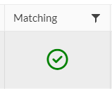

* + - A non-match will appear as a red X in the “Matching” column.

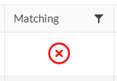

* + - You can click the red X in the “Matching” column to view what eligibility criteria the student did not meet in the “Matching Status” window.
      * See below for an example of a non-matching student and what it looks like when they do not meet eligibility criteria, as seen from the “Matching Status” pop-up window:

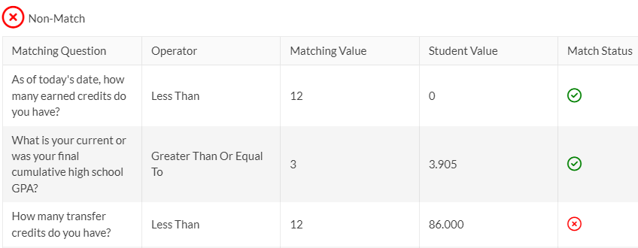

* + - * **Matching Question:** the question or eligibility criteria that the scholarship uses to match students to the scholarship.
      * **Operator:** the operator used upon the matching value to determine eligibility based on the student’s value.
      * **Matching Value:** the value, in combination with the operator, which the student needs to meet in order to match to the scholarship.
      * **Student Value:** the student’s value, which can be anything from yes, no, major, credits, GPA, etc.
      * **Match Status:** shows if the student meets the eligibility criteria listed in the matching question.
        + If they match the eligibility criteria, a green check mark is displayed.
        + If they do not match the eligibility criteria, a red X is displayed.
  + **View:** by clicking on the binoculars, you can see the specific scholarship’s details, including matching requirements, questions, deadline, etc.

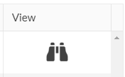

#### Matches Category

* Use the Matches Category to view the scholarship(s) students have matched to and the basic information, such as the name, status, application opening and deadline, etc. Non-matches won’t be shown in this category.

#### Direct Award Category

* Use the Direct Award Category to view the direct award scholarships students have matched to and the scholarships’ basic information, such as the name, status, organization, etc.
* On the Direct Award Category page, only direct award scholarships that the student matched to are shown. Non-matches won’t be shown in this category.
* The student cannot see these scholarships, but if they match to the scholarship, they are automatically considered in the awarding process.
* On the Direct Award Category’s page, it does not have the “Apply Between” column. Instead, it has the “Remaining Budget” column. Additionally, this category has an “Award” column.
  + **Remaining Budget:** the amount of money left in the scholarship’s budget to award students.
  + **Award:** by clicking the $ sign, you can nominate the student for the scholarship and award them.

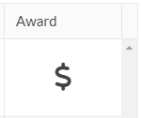

* + - **Do not nominate or award a student without clearance from your supervisor or a scholarship team member.**

#### PINNED CATEGORY

* Use the Pinned Category to view the scholarships that the student pinned on their account to allow for easier access to the scholarship.
* You can also view the scholarship’s basic information like the name, status, organization, etc.

#### Partial Matches CATEGORY

* Use the Partial Matches Category to view the scholarships students did not match to because of only one eligibility criterion.
* You can view the scholarships’ basic information, such as their name, status, application opening, and deadline.
* This category is useful to figure out why a student is not eligible for a scholarship.
* Matches won’t be shown in this category—only partial matches. Click on the red X in the “Matching Column” to view what eligibility criteria the student did not meet, as shown in “1.1.4 SCHOLARSHIPS TAB.”

#### Application Submitted CATEGORY

* Use the Application Submitted Category to view scholarships students have already applied to.
* You can view the scholarships’ basic information like the name, status, organization, etc.
* Only scholarships that the student completed an application for **and submitted** are shown in this category.

#### Non-Matches CATEGORY

* Use the Non-Matches Category to view scholarships students did not match to for more than one eligibility criterion.
* This category is useful to figure out why a student is not eligible for a scholarship.
* Matches and partial matches will not be shown in this category—only non-matches. Click on the red X in the “Matching Column” to view what eligibility criteria the student did not meet, as shown in the “1.1.4 SCHOLARSHIPS TAB.”

#### NoT Interested CATEGORY

* Use the Not Interested Category to view scholarships students matched to but clicked “not interested” when viewing their scholarship matches.

### Applications Tab

* The “Applications” tab allows users to view detailed information about the applications that the student started or submitted and the scholarships they applied for.
* A screenshot of a computer screen

  Description automatically generatedThere is a drop-down menu containing two categories, as shown below:
* There are five columns on each category’s page, as pictured below:



* + In Progress:
  + Submitted:



* + **Application:** the name of the application.
  + **Apply By:** the application’s deadline, meaning the application closes after the date listed.
    - This column is only listed on the In Progress Category page.
  + **Last Updated:** the date and time that the application was edited by the student.
    - This column is only listed on the Submitted Category page.
  + **Academic Year:** the school year that the application is for, meaning the aid year that the student would receive the awarded scholarship(s) that the application applies to.
  + **Organization:** the application’s organization or school/college the scholarship(s) is/are offered through.
  + **Blank:** in the far lefthand corner, there is a blank, unlabeled square column with + signs below it. Click on the + signs to view the scholarship(s) that the application applies to.

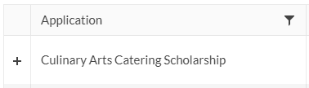

* + - Clicking on the + shows the scholarship(s), and an additional six columns:
      * **Scholarship:** the name of the scholarship(s) the application applies to.
      * **Deadline:** the specific scholarship’s deadline.
      * **Available Spots:** always set to “No Limit.”
      * **Amount:** usually displays “Varies,” as the amounts vary from year to year and student to student.
        + It is not recommended you trust the award amount listed in this column if there is anything other than “Varies.”
      * **Remaining Budget:** the amount of money left in the scholarship’s budget to award students.
      * **View:** displays the binoculars icon.
        + Click on the binoculars if you wish to see the scholarship application’s question(s) and the student’s answer(s). A pop-up window, “View Application,” will appear, displaying the following:

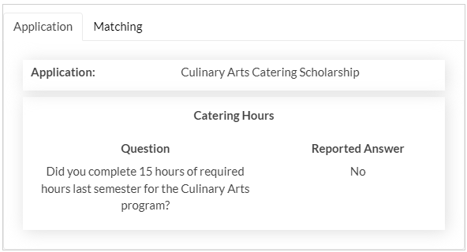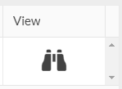

#### In Progress CATEGORY

* Use the In Progress Category to view the applications the student started but **did not** submit, and the applications’ details. You can also view the corresponding scholarships for each application the student started.

#### Submitted CATEGORY

* Use the Submitted Category to view applications, and their corresponding scholarship(s) that students completed **and submitted**.

### Awards Tab

* The “Awards” tab shows the scholarship(s) the student has been awarded and provides information about the award(s).
* A screenshot of a computer

  Description automatically generatedThere is a dropdown menu listing two categories:
* Each category’s page has the following columns:
  + **Scholarship:** the name of the scholarship offered to the student.
  + **Award Year:** the academic year the scholarship is applicable for.
  + **Award Amount:** the amount the student has been offered.
    - To view the specific amounts offered per semester within the award year and any comments made by a scholarship counselor associated with the award, click the underlined amount listed:

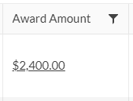

* + - * A screenshot of a computer

        Description automatically generatedThe Award Applicant pop-up window will appear as such:
  + **Award Date:** the date the student was initially awarded the scholarship.
    - This column is only shown on the Awards Category page.
  + **Acceptance Criteria:** displays the binoculars icon.
    - This column is only shown on the Awards Category page.

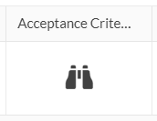

* + - Click on the binoculars to view the scholarship’s acceptance criteria, which are the terms and conditions that the student views upon acceptance of the scholarship.
  + **Status:** shows the scholarship’s award status, which could be listed as 1 of 8 different statuses.
    - This column is only shown on the Awards Category page.
    - Award Status terminology:
      * **Promoted:** the student has been nominated or added to the candidate’s list for a scholarship. **This status does not guarantee the student being awarded the scholarship.**
      * **Pending Approval:** the student has been awarded an amount for the scholarship but is waiting for a scholarship counselor to review and approve the award. **This status does not guarantee the student being officially awarded the scholarship.**
      * **Pending:** the student’s scholarship award has been approved, but the student has not yet been notified. **This status does not guarantee the student being officially awarded the scholarship.**
      * **Offered:** the student has been notified of having been awarded the scholarship and needs to accept it by the deadline. Once a student is notified, a scholarship award notice is sent to their email automatically. **They have now officially been awarded the scholarship.**
      * **Ready to Post:** the student has accepted their scholarship, but a scholarship counselor has yet to post it.
      * **Posted:** the student’s accepted scholarship has been posted and loaded into Banner unless there is an error, in which case any scholarship in a “Posted” status that has not loaded into Banner will be caught on the 01 SCHL Error Report the following business day.
      * **Removed:** the student’s scholarship has been canceled.
      * **Declined:** the student rejected their scholarship award offer.
  + **Deadline:** the date the student needs to accept the scholarship by or risk having the scholarship offer canceled.
    - This column is only shown on the Outstanding Category page.
  + **Matching:** displays the binoculars icon.
    - Click on the binoculars to view the student’s match history to the scholarship.

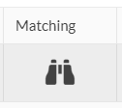

* + - * The Match History pop-up window includes information like the dates the student was matched to the scholarship, the criteria they met to be matched to the scholarship, the changes in award status, etc.
  + **History:** displays the binoculars icon.
    - Click on the binoculars to view the student’s scholarship award history.

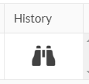

* + - * The Award History pop-up window includes information like the dates the student was matched to, offered, accepted, declined, etc., the scholarship. The window also shows the user history, which includes who promoted, offered, posted, adjusted, canceled, etc., the award.

#### Outstanding CATEGORY

* Use the Outstanding Category to view the details of the scholarship(s) the student is **offered but has not accepted.**
* The page has six columns:

#### Awards CATEGORY

* Use the Awards Category to view the amount and other details of the scholarship(s) the student has ever been offered or is currently being offered. **All awards, no matter the status, are listed on this page.**
  + **Any awards given to the student before switching from AcademicWorks to ScholarshipUniverse will not be shown on ScholarshipUniverse but will be on Banner.**
* 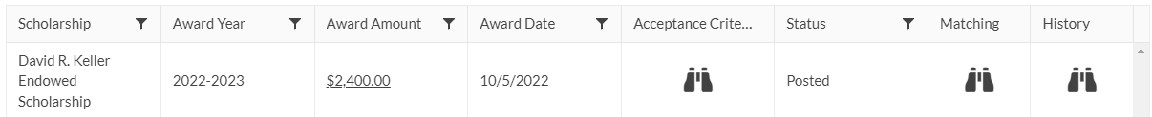The page has eight columns:

### Documents Tab

* A screenshot of a computer

  Description automatically generatedThe “Documents” tab shows the document(s) the student uploaded for a scholarship, like the WUE and Sterling Scholar recipients’/candidates’ documents required to apply.
* There is one dropdown menu with two categories:
* On the right side of each category’s page, there will be a green box.
  + **This button only appears for those who have Admin access.**



* + You can click the box to upload a file for the student.
  + The “Add +” box brings up a pop-up window which appears as such:

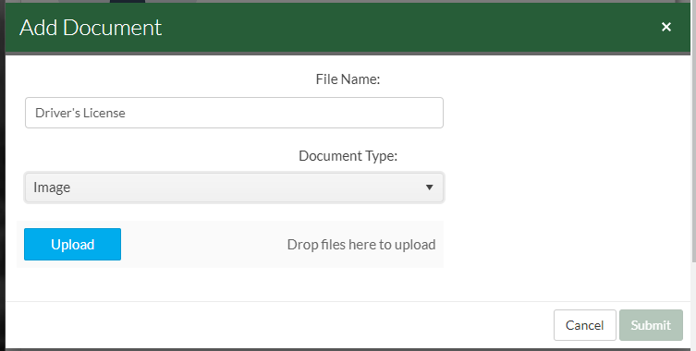

* + - Add the File Name and choose the Document Type for the blue Upload button to appear. Once you have finished uploading the document, click “Submit” to save it to the student’s account.
* A screenshot of a computer

  Description automatically generatedOn each category’s page, there are five columns:
  + **Name:** the name the student chose to assign to the uploaded file.
  + **Document Type:** the format of the documentation uploaded, like “Image” or “Video.”
  + **Last Modified:** the last date the student or a counselor edited or uploaded the file.
  + **Edit:** displays a pencil symbol. Click the pencil to edit the document’s name.
    - **This column only appears for those who have Admin access.**

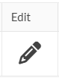

* + **View:** displays the binoculars symbol. Click the binoculars to view the documentation provided.
    - If you cannot view the documentation in the pop-up window, click the following link in the bottom right-hand corner of the window to download the file:

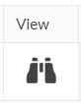

#### Inactive CATEGORY

* Use the Inactive Category to view the documents the student has marked as inactive.

#### active CATEGORY

* Use the Active Category to view the documents the student has uploaded.

### Activity Tab

* The “Activity” tab displays the details regarding the various actions taken on the student’s account.
* A screenshot of a computer

  Description automatically generatedThere is one dropdown menu with four different categories:
* On each category’s page, there are five columns:

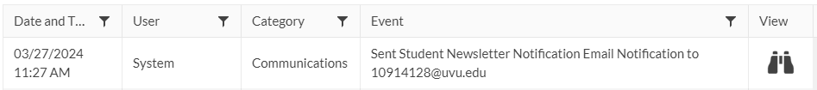

* + **Date and Time:** the date and time the event or action took place on the account.
  + **User:** the name of the user who is behind the event.
    - If it is an automated event, the user is listed as “System;” otherwise, only the student’s or scholarship counselors’ names should be listed.
  + **Category:** the type of event which occurred, explained further in 1.1.8.1—1.1.8.4 below.
  + **Event:** the details of the event that took place.
  + **View:** displays the binoculars icon.
    - A screenshot of a phone

      Description automatically generatedThe binoculars are grayed out unless the type of event falls under the Communications Category.
    - To view a copy of the email sent to the student, click on the binoculars.

#### User Activity CATEGORY

* Use the User Activity Category to view the actions taken on the student’s account by scholarship counselors or the student, as well as the details of each event.

#### Communications CATEGORY

* Use the Communications Category to view the details for the emails sent to the student.

#### Logins CATEGORY

* Use the Logins Category to view the details for when the student logged into their ScholarshipUniverse account, including the IP address they used.

#### ALL CATEGORY

* Use the All Category to view all the activity taken on the account. This category page includes all the aforementioned categories’ activities.